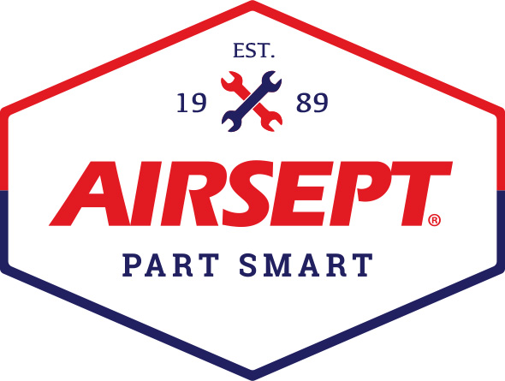

News Release

AirSept Introduces 2022 HVAC Product Catalog and
Smart Splice™ Product Line at the 2022 AHR Expo

Atlanta – January 25, 2022 – AirSept, an award-winning solutions provider for the automotive industry, is excited to share their innovative braze-free line connectors, filtration and odor abatement products developed specifically for the HVAC repair industry with its 2022 HVAC product catalog. The new catalog and HVAC products will be located at AirSept’s booth, #N8813, in the North Hall at the 2022 AHR Expo in Las Vegas scheduled for January 31- February 2, 2022.

AirSept’s HVAC catalog features the company’s Smart Splice™ line connection system designed to repair or reroute damaged metal HVAC lines braze-free with only a wrench, no special tools or adhesive required. The patented sealing technology works with any metal line - copper, aluminum or steel and withstands vibration and compensates for out-of-round tubing better than any option on the market. Smart Splice connectors are burst tested to 2,600 PSI ensuring a durable, long-lasting connection. Smart Splice products include flare to line connectors, straight fittings (SAE or Metric), 45- and 90-degree connectors, connectors with a service port, expanded tube/service valve line connectors and line terminators. All connectors are available as a single item or as a five-pack set.

Other products on display at AHR will be AirSept’s Pro Grade Oil/Dye Injector, Sight Glass Diagnostic Tool to check charging levels, the Recycle Guard™ filter that traps debris, sealant, lubricant, dye, and other contaminants as it exits the HVAC system and EVAP Shield™ to protect against odor causing microorganisms and premature corrosion of the evaporator.

AirSept president and owner, Aaron Becker, says, “AirSept is recognized for developing the most innovative solutions that work. Everyone knows that installing and replacing damaged metal lines can be labor intensive and costly. Too, there is an added risk when using a flame. Our goal at AirSept is to develop products that make your job easier. We hope that if you are attending the 2022 AHR Expo you will take the time to stop by for a demonstration and learn more about the many products we have developed specifically for this industry.”

To learn more about AirSept’s innovative line repair solutions for the HVAC industry view this video.
To download the new HVAC catalog, visit www.airsept.com, or for more information about AirSept’s HVAC and automotive repair products call 800.999.1051, or email information@airsept.com.

# # # #

Image Attached: 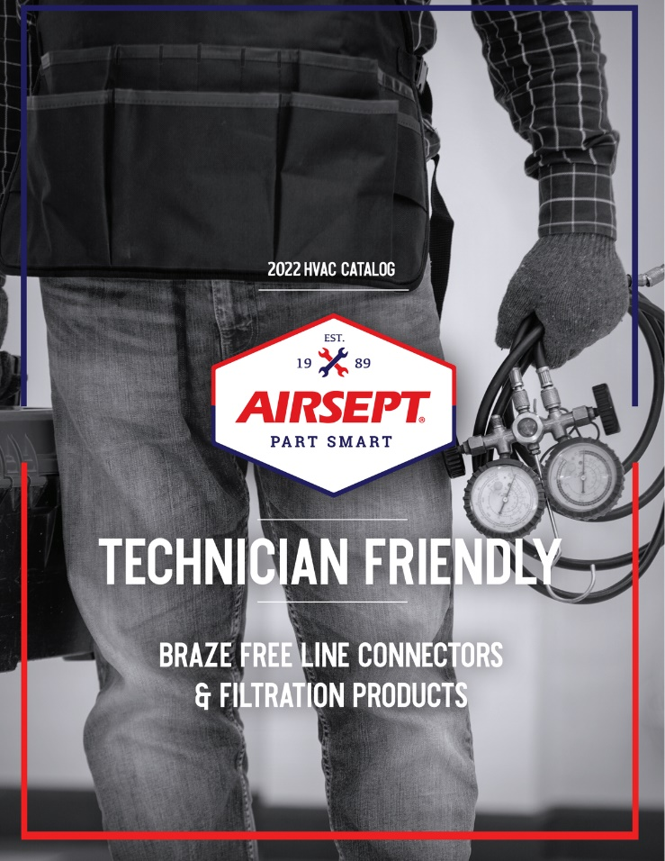

About AirSept
In 1989 AirSept created the first long-lasting solution to the problem of unwanted mold and mildew odor in automobile air conditioning systems. The product quickly became popular and in 1991 AirSept was incorporated as a company. AirSept began partnering with global OEMs and suppliers to not only market its Cooling Coil Coating, but to also develop other unique, new problem-solving products. From those humble beginnings, AirSept has grown to be the industry leader in the development of OEM and aftermarket solutions to complex repair problems. AirSept products are designed to save time, money and labor. For more information, visit AirSept.com.

For further product information, contact:
Aaron Becker, President
AirSept
678-973-2287
abecker@airsept.com

Leslie Allen
Owner
Wildcat Communications
615-429-7965
leslieallen.wildcat@gmail.com

